Guidelines for Inspecting Moisture Infiltration
in Basements & Crawl Spaces
November 2015

Table of Contents

- The effects of moisture infiltration
- How moisture enters a basement or crawl space
- Common causes for moisture infiltration in a basement or crawl space
- Common indicators and levels of moisture infiltration
  - Severe Moisture Infiltration
  - Moderate Moisture Infiltration
  - Minor Moisture Infiltration
  - Moisture from Condensation
- Introduction to mold
- Common corrective measures
- List of supporting references used and links to additional information

Use:
This document is intended to help Rain Check contractors assess the level of moisture infiltration in basements and inform their recommendations for stormwater management tools accordingly. In Section IV, each level of moisture is followed by guidelines (in red bold text) for stormwater management tools on properties exhibiting that level of moisture. The common corrective measures section is background information in case a homeowner asks for more information. Rain Check does not pay for these corrective measures unless they are inherent to the installation of a stormwater management tool.

Preparation:
This document was drafted by Start Smart Energy Use, LLC and reviewed and edited by Philadelphia Water.

- The effects of moisture infiltration:
- Moisture problems in existing basements or crawl spaces are very common and can range in severity depending on the source of moisture.
- The severity of moisture infiltration can vary with respect to the location of the property, the level of the water table, the amount of rainfall that occurs, and the existence and/or condition of the exterior and interior drainage barriers.
- It is a common misconception that because a basement is used less frequently and is separate from the main living space that moisture is not a problem, however most basements are connected to the rest of the house via ductwork, pipe and wire penetrations, mechanical chases, wall cavities, etc.
- Moisture that enters or is generated in the basement is spread through a home and even into the attic at these points along with rising conditioned air via the “stack effect”.
  - This is caused when rising warmer conditioned air above creates a negative pressure on the basement and draws moist air into the basement through cracks, openings in the foundation, floor slab, or uncovered or improperly covered sump pits.
  - The moist air that is drawn in from the exterior mixes with other moisture that may be infiltrating or seeping into the basement and is carried upward into the home.
  - Moisture can also enter the ducting of poorly sealed ducts or return air vents in the basement and be spread throughout the home and also cause mold to form inside the ducts.
- Moisture infiltration at the basement will first deteriorate finishes (“parging”, wall paper, paint, gypsum board, wood paneling, trim, etc), and if left uncorrected will also lead to structural failure of the floor joists, wall framing, and can even contribute to roof failure over time.
- Moisture infiltration also leads to mildew, mold and other biological growth that can lead to poor indoor air quality and significant health problems for the occupants as it is also spread through the house.
- Moisture issues are commonly associated with insect (termites) intrusion and related damages.

- How moisture enters a basement or crawl space:
- There are three (3) types of moisture intrusion that occur in a basement: bulk, condensation and interior
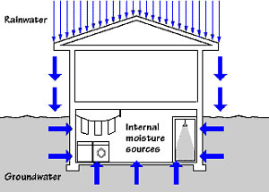
Figure 1 – How moisture enters a Basement.

  - Bulk (liquid) water from ground-water, rain, or snow: Moisture is transferred from the outside to the basement by one or multiple of the following means:
- Liquid water flow: Typically a result of ground-water infiltration, or seepage from defects in the foundation system or its ability to handle hydrostatic pressure and water drainage, improper slope of the grade away from a foundation or breaks in the impervious drainage “plane” around a foundation, or a missing or damaged gutter & down spout systems. This method has the potential to be the most damaging moisture transport mechanism.

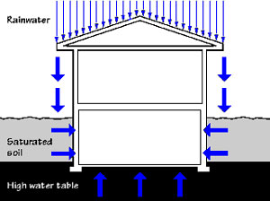
Figure 2 – Liquid water flow.

- Capillary suction: Moves moisture through porous materials such as stone, concrete, or masonry. It is drawn upward through the small pores in a concrete footing and/or floor slab, or laterally through the walls.

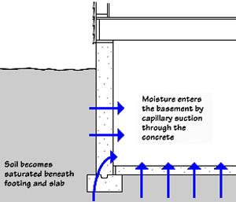
Figure 3 – Capillary suction.

  - Vapor diffusion: Moisture moves in a vapor state through a material as a result of the permeability of the material and the driving force of vapor pressure differential. In a basement, vapor can diffuse from the wetter ground at the outside through the walls and floors towards the dryer interior side of the basement.

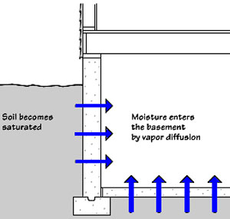
Figure 4 – Vapor diffusion.

- Air transported moisture: Moisture moves via the “stack effect”, or is driven by the wind and drawn in through the joints and porous stone, or open cores of concrete block (CMU) and especially at the top course if it is not grouted solid.

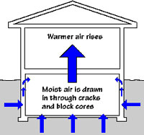
Figure 5 – Air leakage.

  - Condensation: Exterior humid air that enters a basement and condenses on cooler surfaces. If basement windows are opened for fresh air, are in poor condition, or if masonry walls above grade are in deteriorated condition warm humid air will move into the basement and condense on the cooler basement walls and floor surfaces.

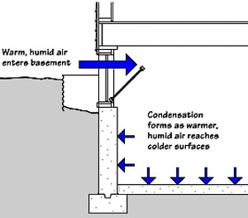
Figure 6 – Condensation.

  - Interior moisture: created by humidifiers, un-vented clothes dryers, showering, cooking, or pipe leaks. Moisture is generated inside the basement by people and their activities.
    - These activities increase if a basement is finished.
    - Another source that could be classified as interior moisture is moisture contained in new concrete after construction.

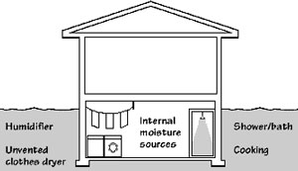
Figure 7 – Interior moisture.

- Common causes of moisture infiltration at a basement:
- The majority of older homes lack an appropriate subsurface drainage system (exterior drains at footing), or impervious coating (asphalt, rubber membrane, “parging”, or other water proofing applied to the exterior of porous stone or masonry walls below grade), or they have failed over time.
- The perimeter concrete or brick drainage plane (patio/apron/sidewalk) is in poor condition (badly cracked, broken up, or low spots) and allows water to penetrate the drainage plane and infiltrate at the walls below the surface.
- Missing, poorly installed, or deteriorated seals at perimeter joint, visible holes or deteriorated mortar/stucco at the intersection of wall and concrete drainage plane, or any pipe penetrations.
- Poor cross slope or pitch of concrete or brick drainage plane (minimum of ¼” per foot) towards any exterior drains.
- Poor grading away from the structure if earth (minimum of ½” per foot over 10 linear feet).
- Improperly designed window wells. (Flat bottom, or pitch towards the wall, no stone sub-base below slab, missing drain).
- Poor seals at windows at or below grade in wells, or at clogged or missing drains at wells.
- Poor seals at exterior doors at bulkheads below grade or at clogged or missing drains at stair bulkheads.
- Missing or deteriorated finish (stucco/parging) or masonry pointing at the interior side of foundation walls above or below grade in the basement or crawl space.
- Missing or clogged area drains or risers that allow water to accumulate along foundation.
- Missing, or damaged downspout and/or gutter allows for concentrated runoff.
- Downspout is disconnected from riser and is not extended a minimum of 5’ – 6’ away.
- Trees, shrubs, or other plantings located next to foundation/exterior walls.
- Receives runoff from, or is due to a defective condition at an adjacent property.

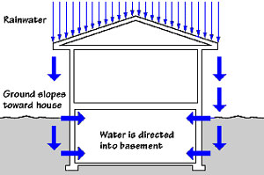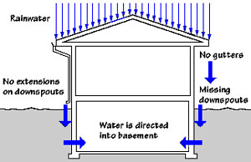
Figure 8 – Example of improper grade. Figure 9 – Example of improper or missing roof
runoff conveyance.

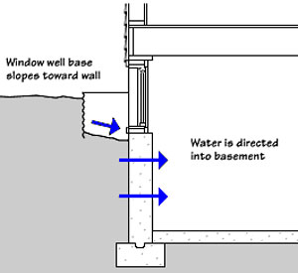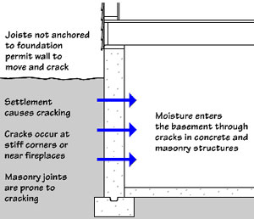
Figure 10 – Example of issue with window well. Figure 11 – Examples of causes of seepage at walls.

- Common indicators and levels of moisture infiltration:

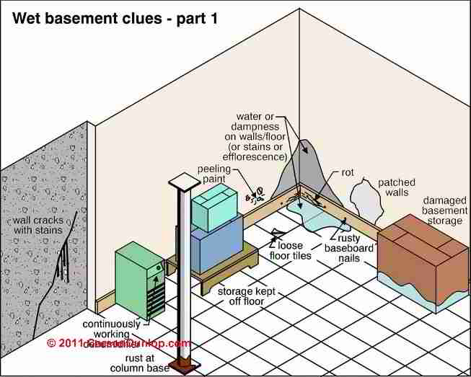
Figure 12 – Common visual indicators. Source: Carson Dunlop Associates

Severe moisture infiltration:
- Ground water infiltration at the perimeter cove joint (where the floor slab meets the vertical foundation wall) is typically responsible for most cases of “severe” moisture intrusion.
- Typically associated with a high water table, an underground spring, or at structures located near a river or stream.
- Occurs on a regular basis.
- Severe ground water infiltration is typically observed consistently at all perimeter walls, but it can also be limited to portions of the basement area.
- There may also be seepage at the bottom of the walls in addition to the cove joint/floor in many cases of ground water intrusion. Especially at the bottom at exterior corners.
- Guideline: A basement with severe moisture as a result of ground water should not be considered for any proposed storm water management tool within 10 feet from the structure or any surrounding structures. Exceptions to this include rain barrels and downspout planters whose overflow and underdrain (planters) go back into the riser.

Common symptoms to look for:
- Strong musty smell clearly experienced upon entry to the basement.
- Standing “bulk” water on floor (verify that water is not from a pipe leak, or other source).
- Surface is consistently visibly wet at floor, cove joint, pipe penetrations, or exterior walls (wet perimeter ring).
- Water trickling out of walls.
- Severe and large areas of mold have also formed at the wet areas.
- Consistent high water mark (stains) or “white ring” of efflorescence at 6”-10” above floor at the perimeter.
- Moisture and/or indicators are also observed at the cove and bottom of the interior demising (party) wall if applicable, or at interior columns.
- Continually or frequently running sump pump. Multiple sump pumps, or sump pumps with an emergency battery back-up system.
- The floor is “troughed” or “pitched” to an open floor drain or open sump pit and is clearly used to convey infiltration. Possibly with standing water in the pit.
- Excessive cracking of the floor slab, wet cracks, and/or “heaved” or broken up concrete floor. Typically associated with heavy clay sub-grade below the floor slab.
- Basement wall is separated by a crawl space or slab on grade and evidence of moisture is still observed.

Examples of severe moisture infiltration:

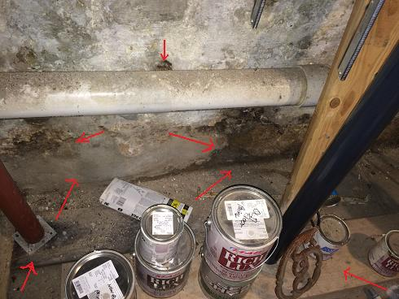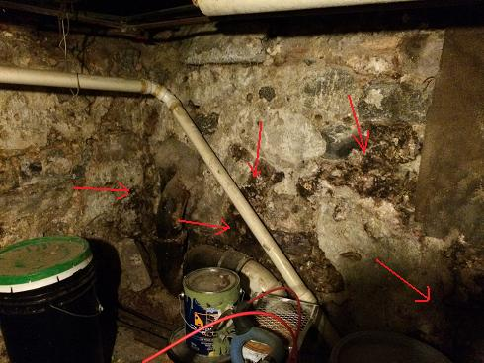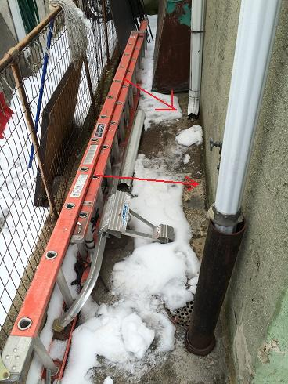
P1 P2 P3
P1 – Ground water infiltration at cove and wall with black mold. Note support column rests on rotted wood block.
P2 – Significant moisture seepage at walls with significant areas of black mold.
P3 – Moisture issues at this location are the result of discharge from downspout along the foundation.

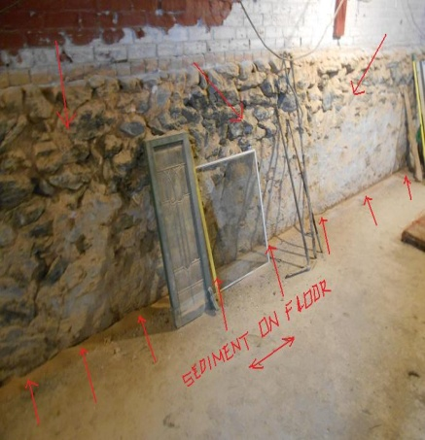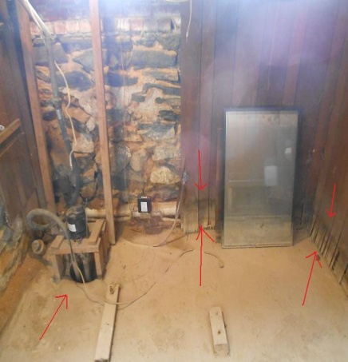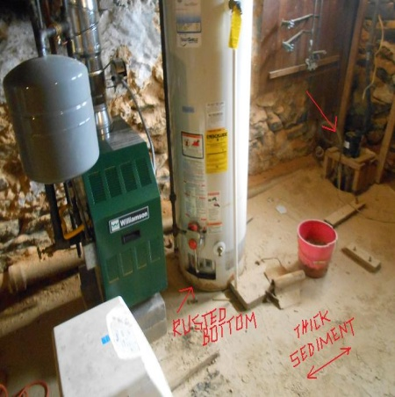
P4 P5 P6
P4 – Stained cove joint and accumulated sediment from ground water infiltration. Also note badly deteriorated joints and finish at the stone foundation wall.
P5 – Rotted bottom of wood panels and open sump pump. Note approximate 6”+ depth of the water mark on panel.
P6 – Thick accumulated sediment and rusted bottom of water heater.

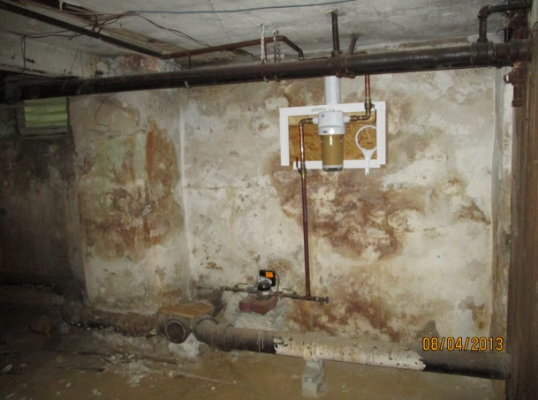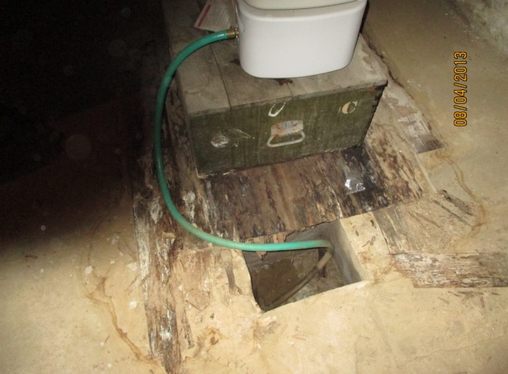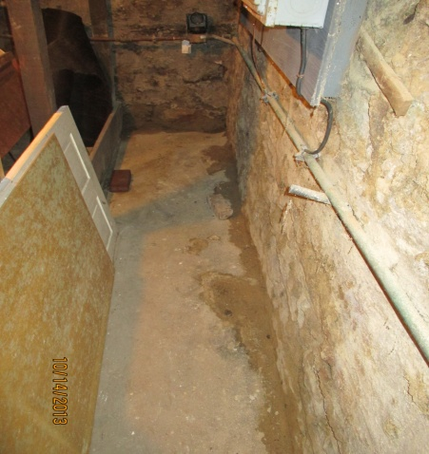
P7 P8 P9
P7 – Example of both ground water infiltration at lower wall and seepage at upper wall at windows and corners.
P8 – Stains, accumulated sediment, rotted bottom of wood panels and open sump pit.
P9 – Consistent wet cove and bottom of the wall (“wet” ring). P9 was taken at a different property than other two.

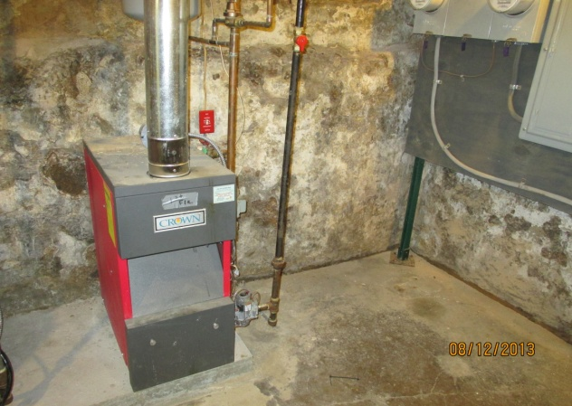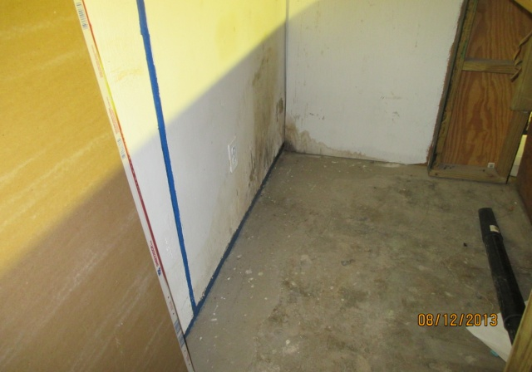
P10 P11
P10 – Example of ground water infiltration at wet cove, floor stain, seepage and the formation of mold at walls.
P11 – Stained, damp, and rotted bottom of wood with formation of mold at drywall at furred out exterior wall.

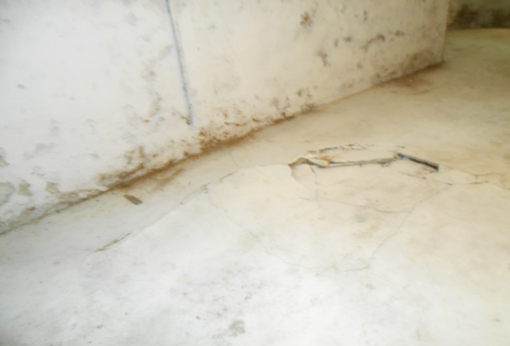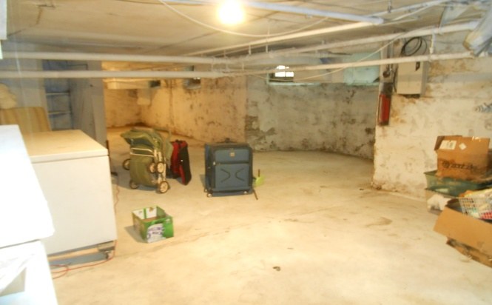
P12 P13
P12 – Example of ground water infiltration at cove and significant cracking and “upheaval” of concrete slab.
P13 – Consistent stains on floor, wet cove, wall seepage, and mold formation at exterior walls.

Moderate moisture infiltration:
- Ground water infiltration can occur at limited locations in a basement and does not necessarily have to extend to all the walls and is also often the source of “moderate” moisture intrusion.
- Seepage typically occurs at breaks in the foundation moisture barrier that is located below grade and is not viewable, but is often a result of a combination of viewable exterior conditions or factors that allow water to infiltrate the drainage plane along the perimeter of the foundation.
- Commonly found at the corners and lower portion of exterior walls, and windows at or in wells below grade.
- Guidelines: Moderate moisture infiltration or seepage indicators should not exist on the inside of the exterior basement walls adjacent to the location of a stormwater management tool. If moderate moisture infiltration is evident, proposed storm water management tools must be 10 feet from the structure or any surrounding structures. Exceptions to this include rain barrels and downspout planters whose overflow and underdrain (planters) go back into the riser.

Common symptoms to look for:
- Strong musty smell clearly experienced upon entry to the basement.
- Sporadic dampness/staining/or sediment at cove joint, floor, or bottom of exterior walls.
- Dampness, stains, sediment at pipe penetrations through floor, walls, and cracks.
- Multiple or large localized areas of damp, stained masonry walls, and “bulging parging” that appears to have been pushed inward from behind the material by pressure from the exterior.
- Multiple or large localized areas of deteriorated mortar joints, and/or “parging” at stone/brick exterior walls. Material and mortar may be on the floor at the base of the wall where it has fallen.
- Multiple or large localized areas of efflorescence at exterior stone/masonry/concrete exterior walls.
  - Efflorescence is a powdery white substance that appears on walls as a result of minerals in masonry and mortar mixing and then left behind when the moisture evaporates.
  - It can form as a result of wall seepage, condensation, or diffusion.
  - It is commonly confused with mold, but is “chalkier” and more “crystal” like than white mold.
- Consistent dampness and/or stains at cold pour joints, or form ties at cast in place concrete foundations.
- Multiple or large localized areas of damp, stained, or soft furred out walls that are finished with drywall or wooden paneling.
- Mold spots at locations consistent with the localized moisture. The mold will be the worse at the locations where the moisture is seeping the worst.
- Consistent missing, loose, or badly stained floor finishes and rubber base (ACT/VCT/sheet goods).
- Rotted/stained wooden framing, paneling, baseboards, windows, doors, joists, stairs, or columns.
- Steel columns, floor plates are rusty at the bottom.
- Rusty screws, hangers, beams, etc throughout the space.
- Metal doors, metal casings at water heater, appliances, furnace, etc are rusty at the bottom.
- Stored items are placed off the floor on pallets, or stained/damp from contact with moisture.
- Sump pump engages on a regular basis when it rains.
- A dehumidifier runs constantly and drains directly into a sink, sump, or floor drain.
- Floor of viewable crawl space lacks an appropriate moisture/vapor barrier (earth floor).
- Visible termite damage (moisture is always a factor associated with termite infestation).
- Visible tree root intrusion near or through exterior walls.
- Basement wall is separated by a crawl space or SOG and evidence of moisture was still observed.

Examples of moderate moisture infiltration:

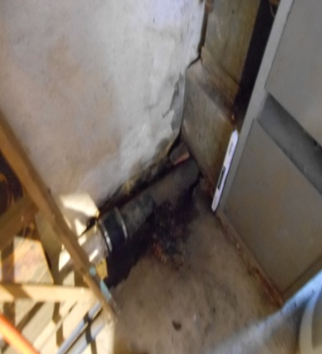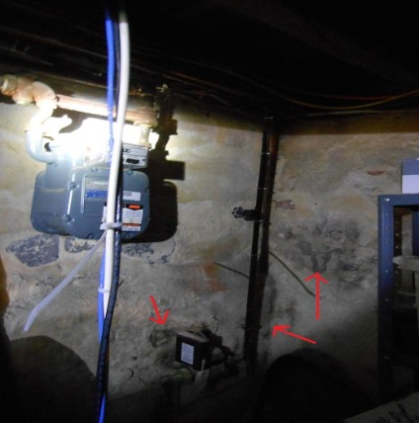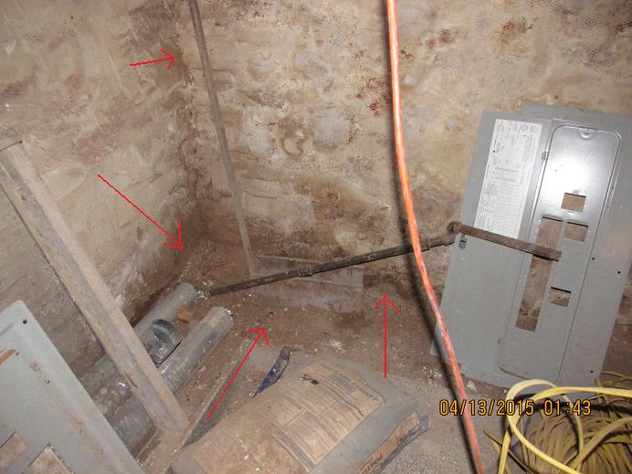
P1 P2 P3
P1 – Infiltration where pipe penetrates the floor slab wood block.
P2 – Moderate moisture seepage at corner of exterior walls with formation of black mold.
P3 – Moderate moisture seepage at bottom corner of exterior walls. (Photo was taken at different property).

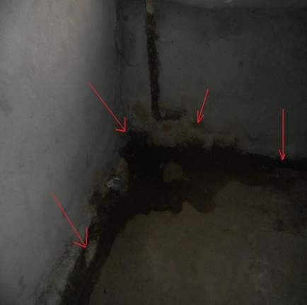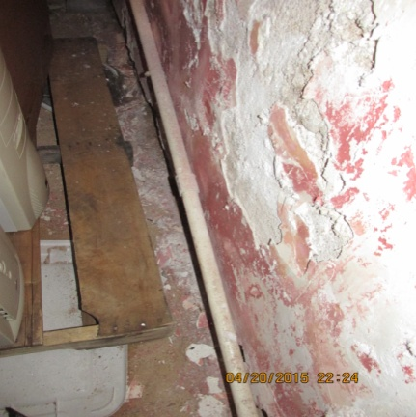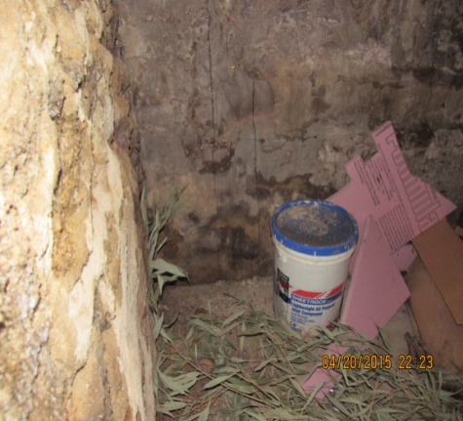
P4 P5 P6
P4 – Limited ground water infiltration at cove and bottom of wall in the corner. Taken at a different property.
P5 – Example of significant efflorescence at an exterior wall. Moisture from the exterior has displaced the finish.
P6 – Moderate moisture seepage and formation of black mold at bottom of wall at an exterior corner.

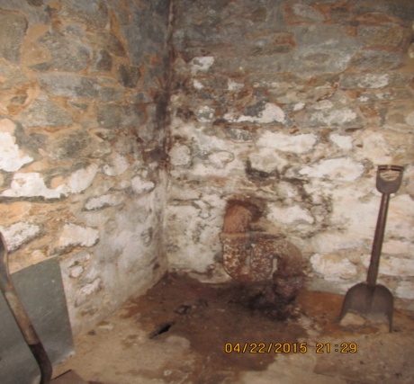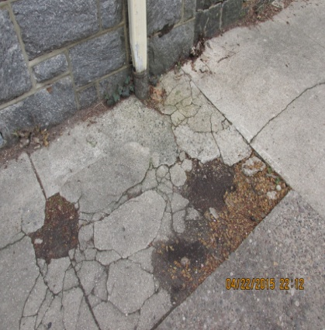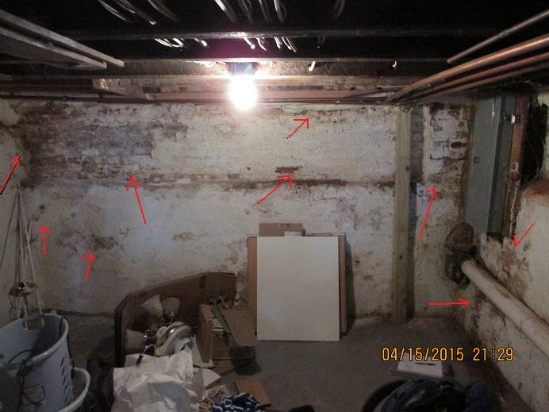
P7 P8 P9
P7 & P8 – Localized seepage at wall with formation of black mold. Moisture was the result of a clogged riser & another open spout above discharging onto & deteriorating the concrete drainage plane at this location.
P9 – Moderate moisture at rear walls. The long stain at top left corner is from a tree next to the foundation. (Photo taken at different property).

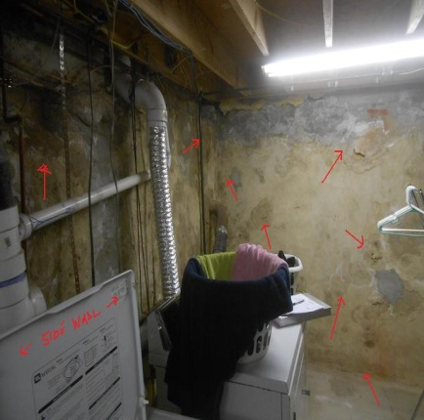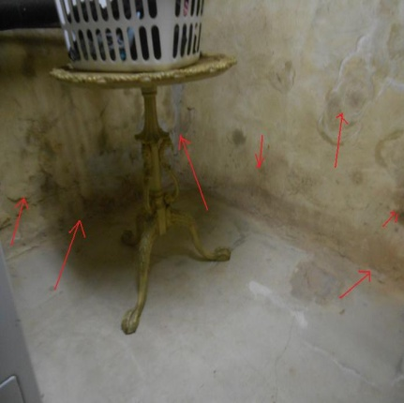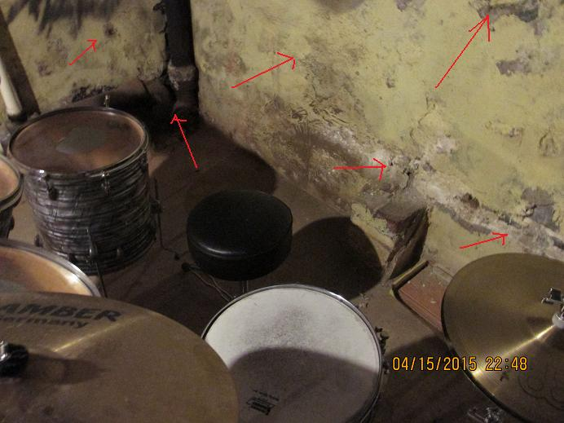
P10 P11 P12
P10 & P11 – Examples of evidence of moderate moisture seepage at corner of exterior walls.
P12 – Moisture seepage and formation of black mold at bottom of wall at an exterior corner. (Different property).

Minor (or localized) moisture infiltration:
- Similar to moderate moisture infiltration but on a lesser scale or at limited locations. It is fairly common to find minor moisture infiltration.
- Ground water infiltration is typically not the source of minor moisture.
- Seepage may also occur at breaks in the foundation located below grade that are not viewable, and more often is the result of an isolated or minor exterior condition or factor that allows water to infiltrate the drainage plane along the perimeter of the foundation.
- Guidelines: Minor moisture infiltration or seepage indicators should not exist on the inside of exterior basement walls adjacent to the location of a stormwater management tool unless they are a result of a clearly correctable issue or have clearly been previously corrected. Exceptions to this include rain barrels and downspout planters whose overflow and underdrain (planters) go back into the riser.
- If a condition exists that allows the perimeter drainage plane and area drain to remain intact for a minimum of 4’ beyond the building and an impervious liner is used per the program criteria, then depaving or permeable pavers may be used.
- Otherwise proposed storm water management tools must 10 feet from the structure or any surrounding structures.

Symptoms to look for:
- Some musty smell is noticeable upon entry to the basement.
- Limited (localized, spotty) dampness or staining or sediment at cove joint limited to applicable location.
- Limited (localized, spotty) damp floor, walls, or cove joint at exterior walls limited to applicable location.
- Localized, spotty locations of deteriorated mortar joints, or “parging” at stone/brick exterior walls limited to applicable location.
- Localized, spotty locations of staining/flaking paint or at exterior walls.
- Localized, spotty or small areas of efflorescence at stone or masonry walls.
- A few spots of mold formation at masonry or furred out walls.

Examples of minor localized moisture infiltration:

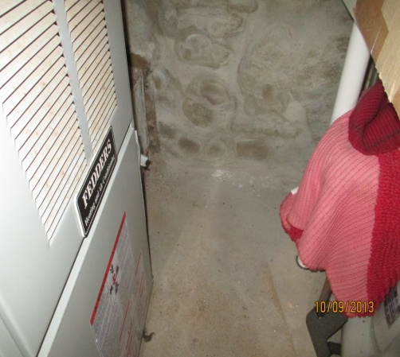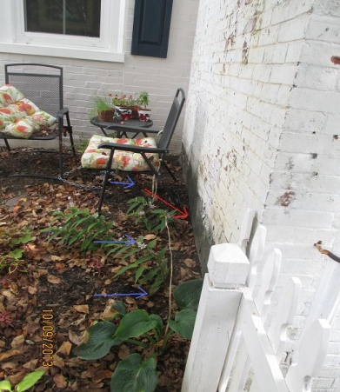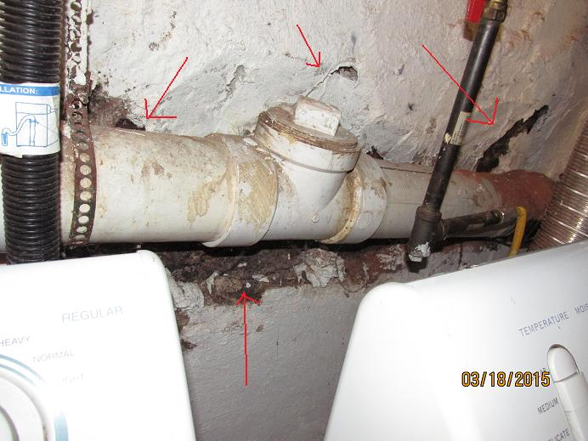
P1 P2 P3
P1 – Example of minor staining from seepage at limited exterior wall location.
P2 – Minor seepage in P1 was a result of an easily correctable grading issue and low spot at the exterior.
P3 – Minor seepage at missing & deteriorated “parging” at wall near a pipe that prevented a proper application.

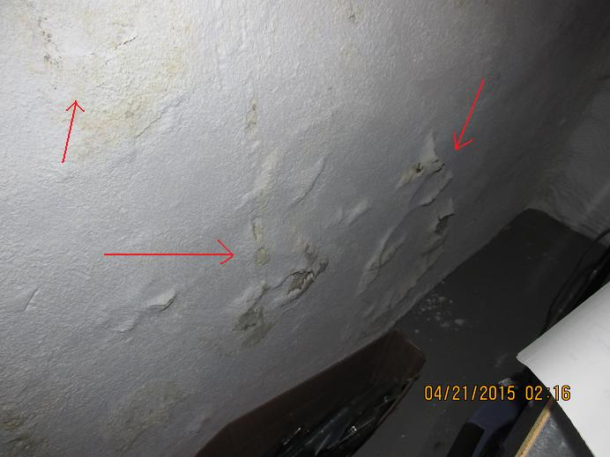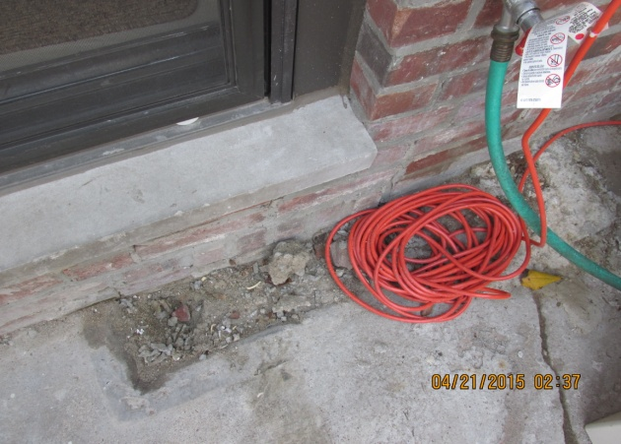
P4 P5
P4 – Example of evidence of minor localized seepage at limited exterior wall location.
P5 – Seepage in P4 was a result of missing concrete at the exterior opposite the indicator.

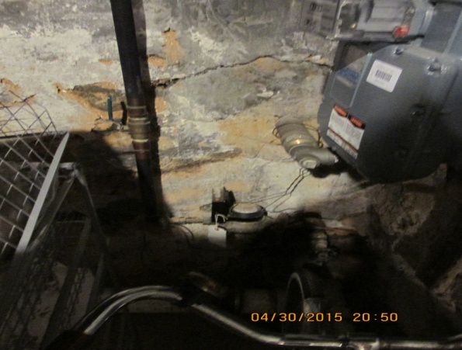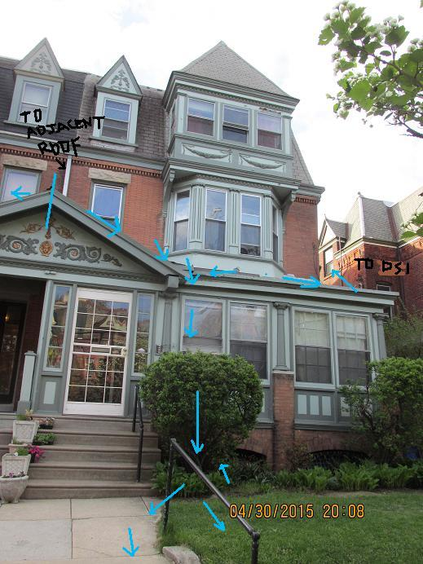
P6 P7
P6 – Example of localized seepage at limited exterior wall location.
P7 – Minor seepage in P6 was a result of uncontrolled concentrated runoff from porch roof at this location.

Moisture from condensation:
- Typically limited to summer months and is dependent upon several factors:
  - Inside versus outside temperatures
  - The relative humidity.
  - The speed of the air moving across the condensing surface (slower moving air takes more time for condensation to form).
- A basement with several windows or doors that may be opened to allow for ventilation, or that are in poor condition is a good candidate for a condensation problem.
- A basement with 3’ – 4’ of exterior walls above grade and/or where the masonry or pointing is in poor condition at both sides is also a potential candidate for condensation.
- These conditions allow for warm, humid air to enter from the outdoors and condense on the cooler surfaces in the basement.
- Moisture infiltration into a basement via another means can also lead to condensation because it increases the level of humidity in the basement.
- Can also be generated internally from people and activities such as running a humidifier, unvented clothes dryer, showering and cooking without using exhaust fans.
- Consider this as a source if other indicators can be ruled out.
  - Especially at cast in place concrete foundation walls that are at least 1 year old.
- Guidelines: This type of moisture would typically not impact the installation of any storm water management tools unless there was is also moisture infiltrating into the basement from another means.

Common symptoms and other things to look for:
- Check for other signs of moisture to help determine if the moisture at walls/floors is potentially from condensation.
  - Water beading at the interior side of windows (especially double pane types).
  - Water beading and/or dripping at metal pipes or ducts.
  - White stains on metal air ducts. Especially if the ducts are stained and they are not used for cooling (no AC).
  - Puddles on floor below drips.
- Moisture is observed during a period of hot humid weather at structure with minimal or no other potential for ground water intrusion or wall seepage.
- Open windows and/or doors in poor condition that would allow for warm humid air to enter.
- Exterior walls above grade are in poor condition and are potential entry points for warm, humid air to enter and where condensation has formed on walls.
- Moisture that may be located higher up on wall and drips/runs down the wall surface.
- The entire or large areas of all the walls (including interior walls) would be affected rather than localized areas.
- Large or consistent areas of staining/blistering wall coverings throughout the space (including interior walls) where damage appears to from the outer side of the surface rather than through the surface from behind.
- There may be beads or small drops of water on the surface of walls or floors or surface appears to be “sweating”.
- Large areas of efflorescence at stone/masonry exterior walls located higher up on walls and adjacent to windows or doors.
- Small spots of mold that appear to be growing on top of the surface rather than through the material as in the case of seepage. Sometimes the mold from condensation on a surface will be “fuzzy” with an outward growth similar to hair.
- Moisture could be generated internally by occupant activity such as showering or cooking, or a dryer that is not vented.
- There is a “humidifier” (not to be confused with a de-humidifier) operating in the basement.

Examples of moisture from condensation:

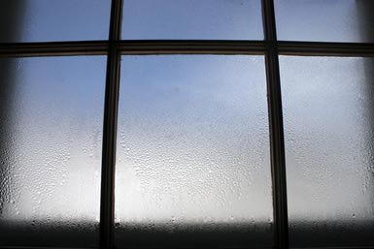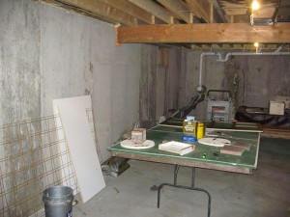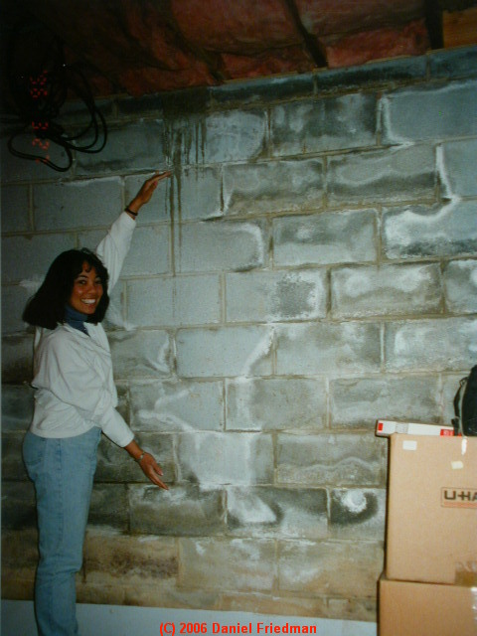
P1 P2 P3
P1 – Condensation will also form as beads at the inside of window.
P2 – Moisture from condensation running down wall in basement with no other issues.
P3 - Moisture issues are the result of both condensation at the top of wall with drips, seepage and ground water at the bottom where the cove is wet and the surface is muddy.

Interior moisture:
- This condition would have no impact on the installation of a storm management tool.
- The indicators are typically localized near the source (near the dryer, in the bathroom).
- Interior moisture can also be the result of the curing process associated with new concrete that is within 1 year of age.

Symptoms and other things to look for:
- If moisture is observed at the floor of the walls in a recently constructed “cast- in- place” foundation or floor slab, and consistently extends beyond and/or is not limited to the locations of pour joints, form ties, or penetrations this is most likely the reason.
- Newer homes are also often constructed with more sophisticated and efficient exterior drainage barriers, and sump pumps that are required by construction codes.

- Introduction to Mold:
- Molds are living microscopic organisms (Fungi) that are found both indoors and outdoors and play an important role as part of the natural environment in breaking down dead organic matter.
- Mold spores are typically floating around indoor environments and cannot be eliminated.
- Mold spores will only grow where there is moisture & digest whatever organic material they are growing on.
- Mold growth at indoor environments should always be prevented as molds have the potential to cause health problems. Especially to people who are allergic.
  - Mold growth in excess of a 10 square foot area is typically considered a health hazard by the EPA.
- The toxicity level of molds vary, but only molds that produce “mycotoxins” are actually toxic, however most molds are capable of causing headaches, dizziness, skin irritations, nasal irritation, fatigue, and nausea.
- There are many different types of mold and molds come in many colors (black, green, red, brown, grey, or white).
- Mold initially appears as a stain and increases in appearance and growth with respect to the amount of moisture and nutrients available.
- It can take on a cottony, velvety, granular, fuzzy, or leathery appearance and form “barnacle” like growth.
- Microbial volatile organic compounds produced by mold often have strong unpleasant odors and are the source of the musty smell associated with a wet basement.
- Mold can be tested for toxicity, but it is typically recommended that it just be remediated.
- There are several ways to clean and remove mold, but it is usually never completely eliminated unless the source of the moisture is corrected.
- It is typically recommended that mold in excess of a 10 SF area be remediated by a certified professional in accordance with EPA guidelines.
- Refer to the references and links for more information.

Examples of mold:
*Also refer to previous photos in the examples of severe and moderate moisture.

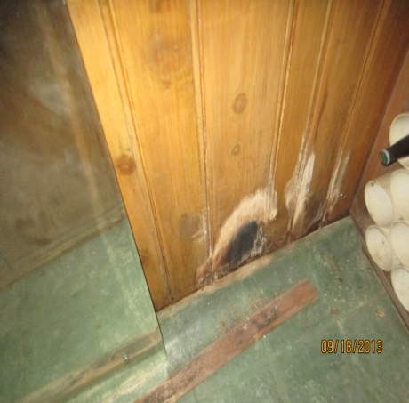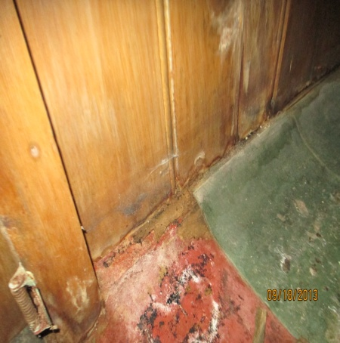
P1 P2
P1 & P2 – Two different types of mold that have formed (black & white) at paneling and floor finishes.

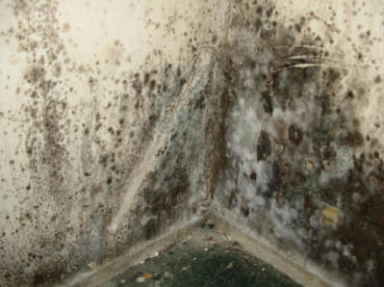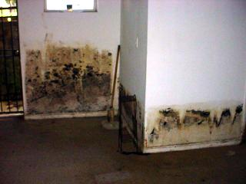
P3 P4
P3 & P4 – Examples of extreme mold. Note both black and white growth. P4 is the result of standing water after a flood.
- Corrective Measures:

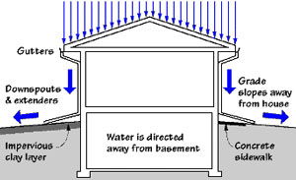
Figure 13 – Direct runoff away from the foundation.

- In many cases of older buildings it is difficult to completely correct any moisture infiltration without performing extensive work at the exterior to install mechanisms and methods that are typically required as part of new construction practices.
- Some of the following measures can be performed to prevent or minimize moisture infiltration, but may require regular maintenance.
- In cases where there is ground water infiltration it should be recommended to consult with a professional water proofing specialist about the installation of a sump pump and/or interior wall drainage system.

Exterior Measures:
- Maintain gutters and downspouts and clean on a regular basis to prevent back up and over spills.
- Inspect roof inlets and clear on a regular basis.
- Extend downspouts a minimum of 6’-10’ from the foundation, or as far as possible.
- Maintain the exterior drainage plane alongside of exterior walls by sealing cracks, patching, re-surfacing, or replacing deteriorated materials.
- Maintain a tight seal at the joint along the exterior walls.
  - Grind out accumulated materials and clean and prepare joint
  - Seal the joint with a minimum of a ½” deep exterior grade sealant with a tooled joint. Use a backer rod for joints over ¼” wide.
- Maintain a minimum ½” per foot of pervious grade over 10’ (5%) from the foundation for runoff away from the walls.
- Maintain a minimum ¼” per foot grade over 5’ (2.5%) at impervious drainage plane away from the foundation.
- Fill low spots and depressions as needed.
- Avoid placing plantings within 2’-4’ of the foundation walls.
- Keep drains clear and free of obstructions.
- Install an exterior drainage system, or water resistant membrane or coating at exterior walls below grade (if applicable or part of a larger construction project such as an addition.

Interior Measures:
- Any materials and finishes with mold in the basement should be cut out and replaced, and other surfaces treated and cleaned with Concrobium or other EPA approved fungicide or method.
- Prepare exposed masonry walls by scraping off deteriorated mortar, efflorescence, dirt, etc.
- Patch deteriorated mortar, large voids, holes, or areas of the worst staining with hydraulic cement. Parge large areas with this product as needed.
- Apply a minimum of 2 coats of masonry waterproofing paint (suck as Drylok or other similar product).
- An alternative would be to prepare walls as described and apply 2” of closed cell urethane spray foam insulation directly to the walls in lieu of the waterproofing paint.
  - This product will not stop ground water infiltration at the cove, but is resistant to moisture penetration through walls, mold, and insects.
  - This product is flammable and would require the application of a 15 minute ignition barrier at this location.
- Don’t ventilate the basement in the summer with outside air when it is humid.
- Run a de-humidifier in the basement to reduce the symptoms of humidity and odor, but do not use it as a sole means or solution.
  - Use of a de-humidifier in a basement with a moisture infiltration issue may actually cause more damage because by drying out the air moisture will be drawn into the basement more rapidly causing efflorescence, deteriorated concrete, “parging”, mortar, and damage to interior finishes.

- List of supporting references, and Figures used and links to additional information:

- Moisture in Basements: Causes and Solutions – Prepared by the University of Minnesota Extension.
www.extension.umn.edu/environment/housing/moisture-management

- Building Science Introduction – Moisture Flow – Prepared by the Building America Solution Center
https://basc,pnnl.gov/information/building-science-introduction-moisture-flow

- A Brief Guide to Mold, Moisture, and Your Home – Prepared by the US Environmental Protection Agency
http://www.epa.gov

- Home Solutions: Damp Basement & Mold and Mildew – Prepared by Energy Star.
http://www.energystar.gov

- Wet Basement Diagnosis & Cure: How to Inspect for Basement Leaks or Moisture – Prepared by InspectAPedia
http://inspectapedia.com/Wet_Basements/Basement_Water_Entry.php

- Healthy, Safe, Moisture & Mold Free Basement Living Space – Prepared by This Is Drywall
http://www.thisisdrywall.com

