Eligibility Criteria: De-paving, Permeable Paving, or Rain Gardens
Update to Rain Check Guidelines – January 6, 2016

One of the primary goals of each Rain Check project is to keep stormwater from residential properties out of the sewer system. Philadelphia Water requires that every project must manage stormwater that would otherwise flow into the sewer.* This is true in areas with a combined sewer or separate sewer.

In most cases, it is easy to determine if stormwater enters the sewer system or if it is already being absorbed into the ground after it leaves a roof, patio, driveway or other hard surface.

In cases where it is less clear, keep these criteria in mind:
- If hardscape is surrounded by a permeable surface, it may not be eligible for Rain Check. When the hardscape slopes towards a permeable area and the flow path over the hardscape area is shorter than the flow path of the permeable area, then Philadelphia Water assumes that the hardscape is already being managed by the permeable area, and thus not eligible for treatment through Rain Check.
- However, in cases where a steep slope of the hardscape or the permeable area causes water to enter the sewer system, then the hardscape area is likely eligible for treatment through Rain Check.

Permeable Paving / Depaving Example
Re-doing the below walkway with permeable pavers would not qualify for a Rain Check cost-share. Even though the lawn is sloped, it is much larger than the hardscape. All of the water running off of this walkway will be absorbed by the lawn and surrounding vegetation.
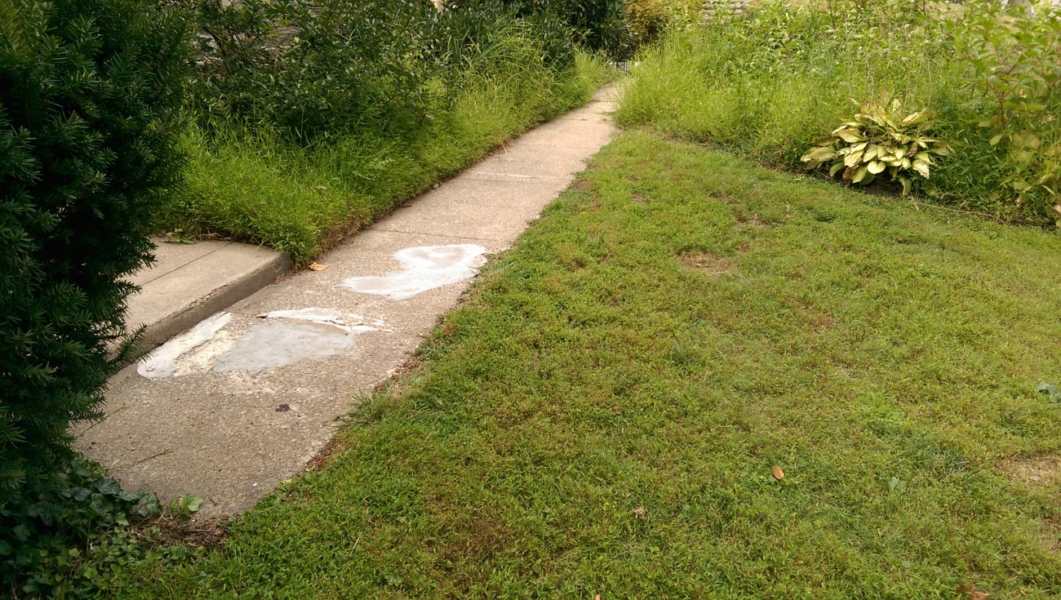

* On occasion, there are some rain garden projects that we have installed where the downspout is already disconnected from the sewer. This happens rarely and only when the installation of the rain garden significantly improves stormwater management on the site.
Permeable Paving / Depaving Example
Re-doing the below front walkways with permeable pavers would not qualify for a Rain Check cost-share. Almost all of the water running off of this walkway will be absorbed by the lawn and surrounding vegetation.

Rain Garden Example
Installing a rain garden here to manage runoff from the patio would not qualify for a Rain Check cost-share. Note: there are no downspouts to disconnect in this example – the rain garden would only manage the patio.
