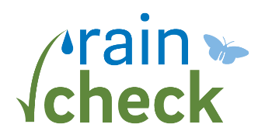 ABREVIATED Consultation report

CLIENT information
Participant Name:
Street Address:
Rain Check Tool:
cONTRACTOR information
Contractor Name
Consultation Date/Time

Feasibility | Yes | No
Is desired tool feasible on this property?
If not, please explain:

If not, are any other Rain Check tools feasible on this property?

Submit this form to Zach Popkin: RainCheck@pennhort.org

